**QUESTION 1**

Below is the graphic user interface GUI-Student Form.

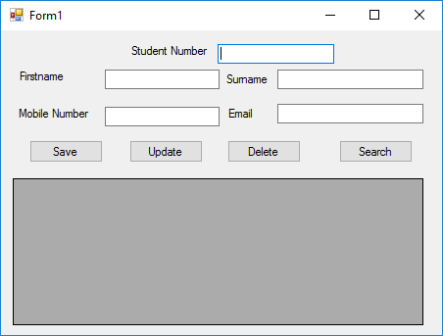

Below is the database table – Student Details

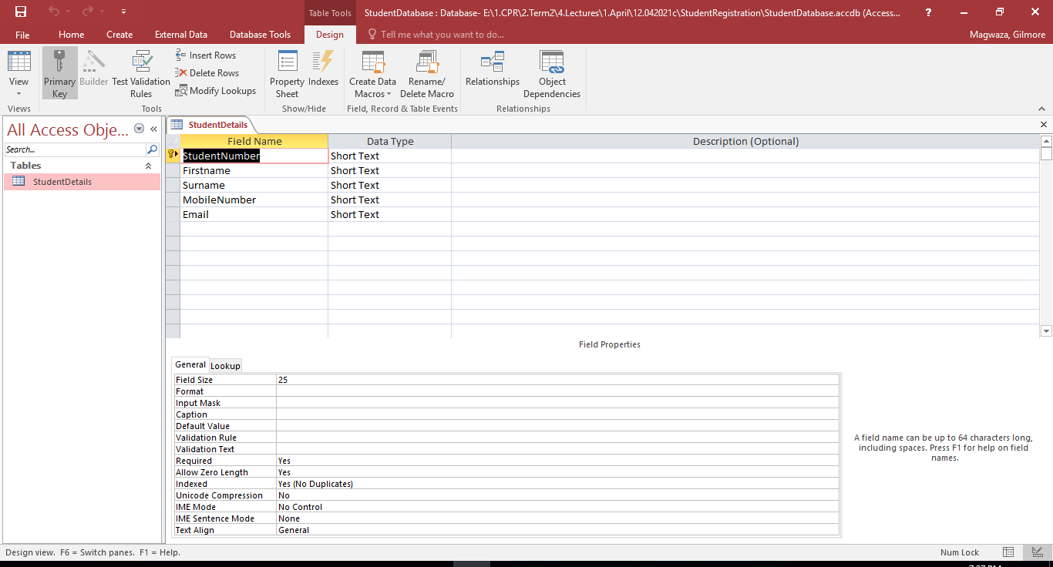

Perform the following operations on the Student database using the Student Form

1. Insert data to the database
2. Edit data in the database
3. Delete data from the database
4. Select data from the data